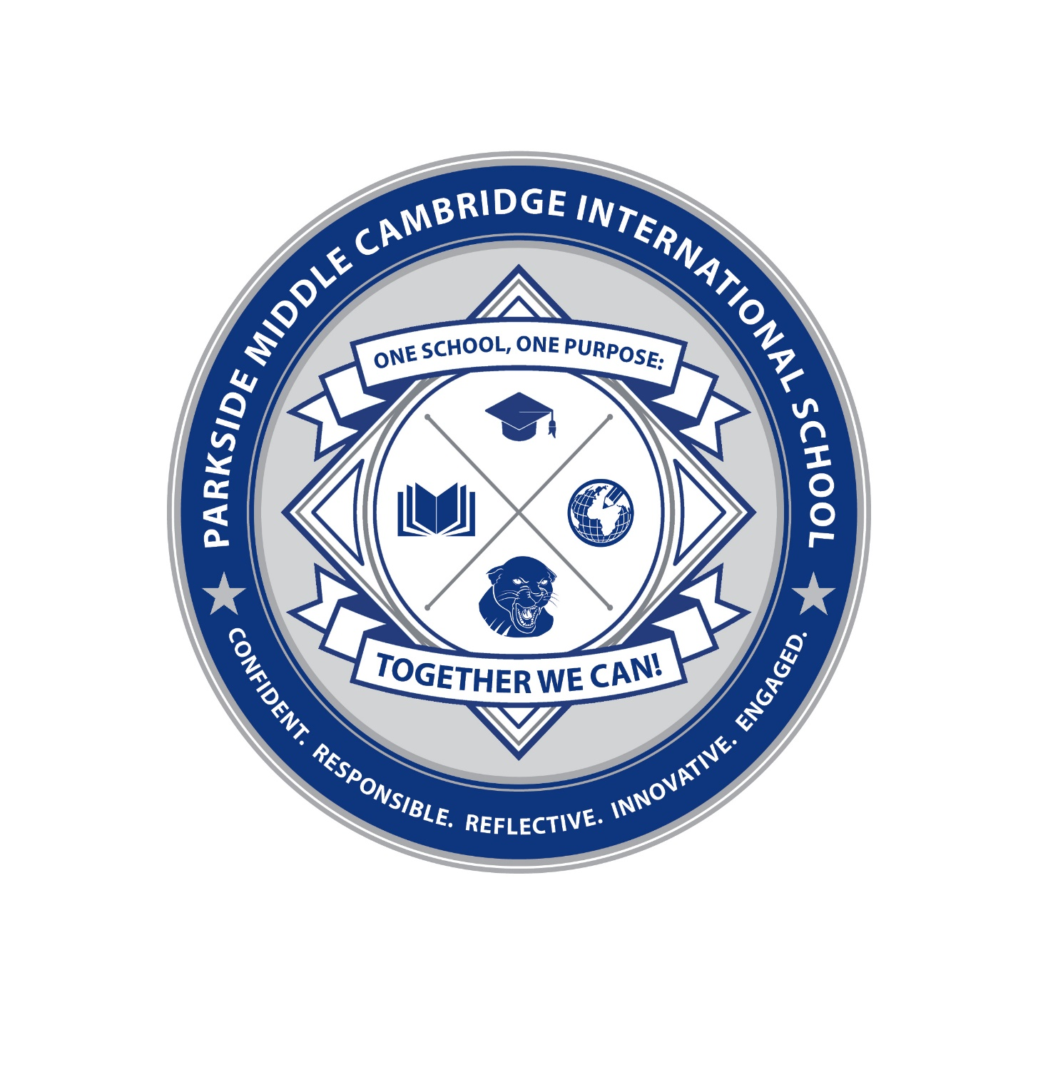
Back to School Supply List
2023 - 2024

  - Pencils
  - Blue/Black ink pens
  - Erasers
  - Highlighters
  - 2- Spiral Notebooks (1 subject)
  - 2-7 – Composition Notebooks
  - 1- Package of Colored Pencils

Recommended (optional)
- Backpack – able to carry a laptop computer
- Headphones
- Re-usable Water Bottle
- A Binder

** No graphic or regular calculators will be needed. Students will use online calculators and Desmos online.

Please remember that all items will be carried in each student’s backpack during the day. Please don’t send additional items to school into school on the first day, unless requested.
Additionally, if further assistance is required please do not hesitate to contact Parkside’s Main Office or Parkside’s Parent Liaison,
Sayra Dominguez – domingSC@pwcs.edu

